INSTRUCTIONS TO ACCESS VRC ARTICLES FROM VRC HOMEPAGE
Step I- Click on Quick links to HS Library
Step 2- Click on Virtual Reference Center
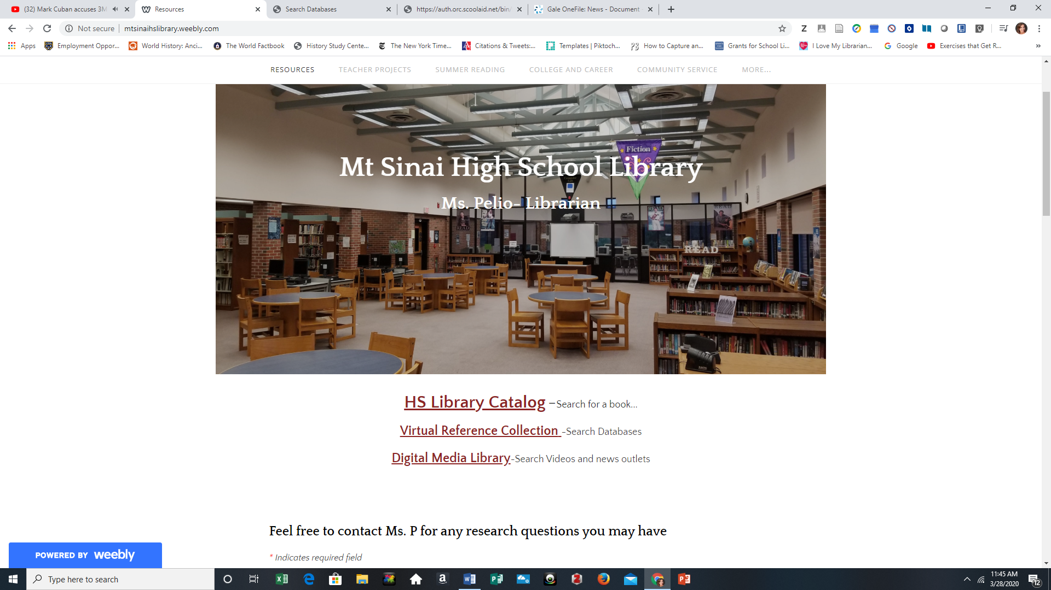
*Username mtsinaihs password mustang
Step 3- Search Topic or subject of your research project
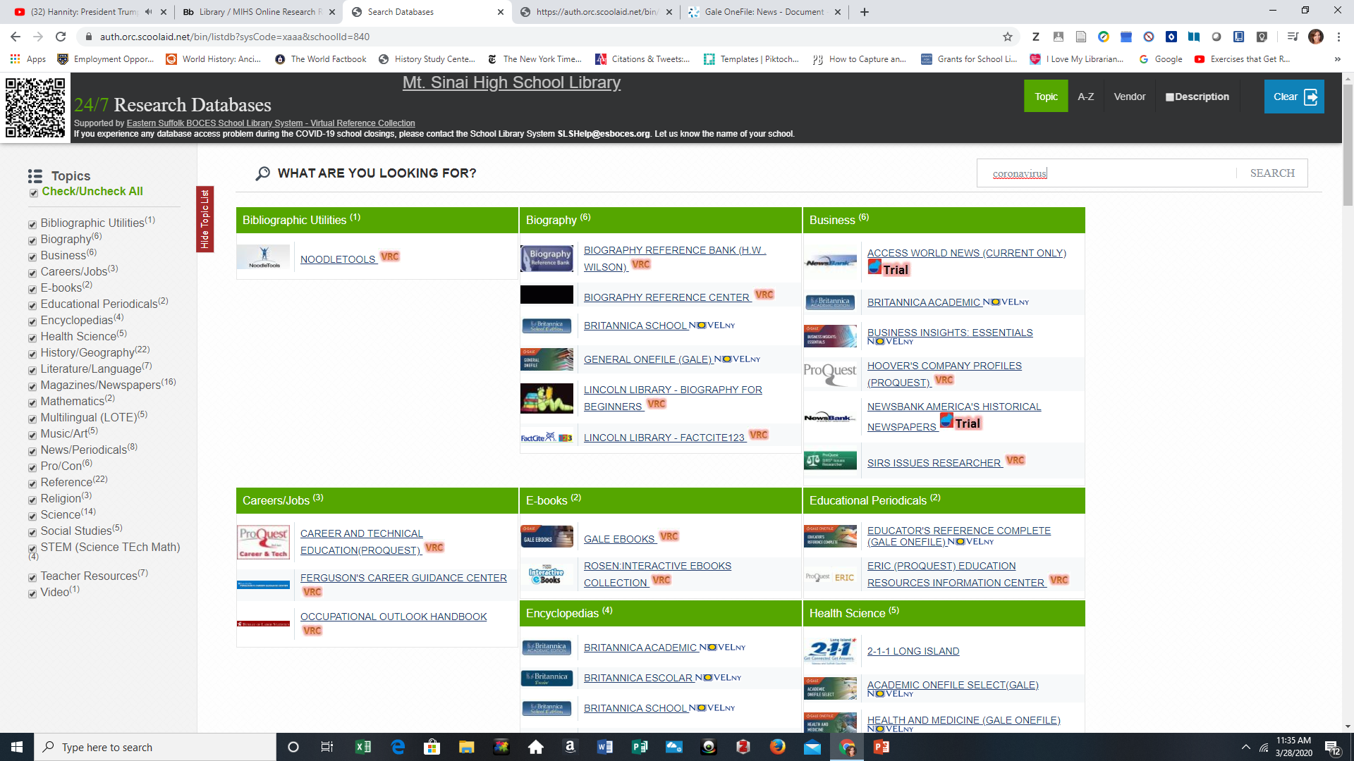
Step 4- Results on Left hand page are Databases and amount of articles found in database
Results on Right hand side of page are specific articles
All Highlighted Blue are links
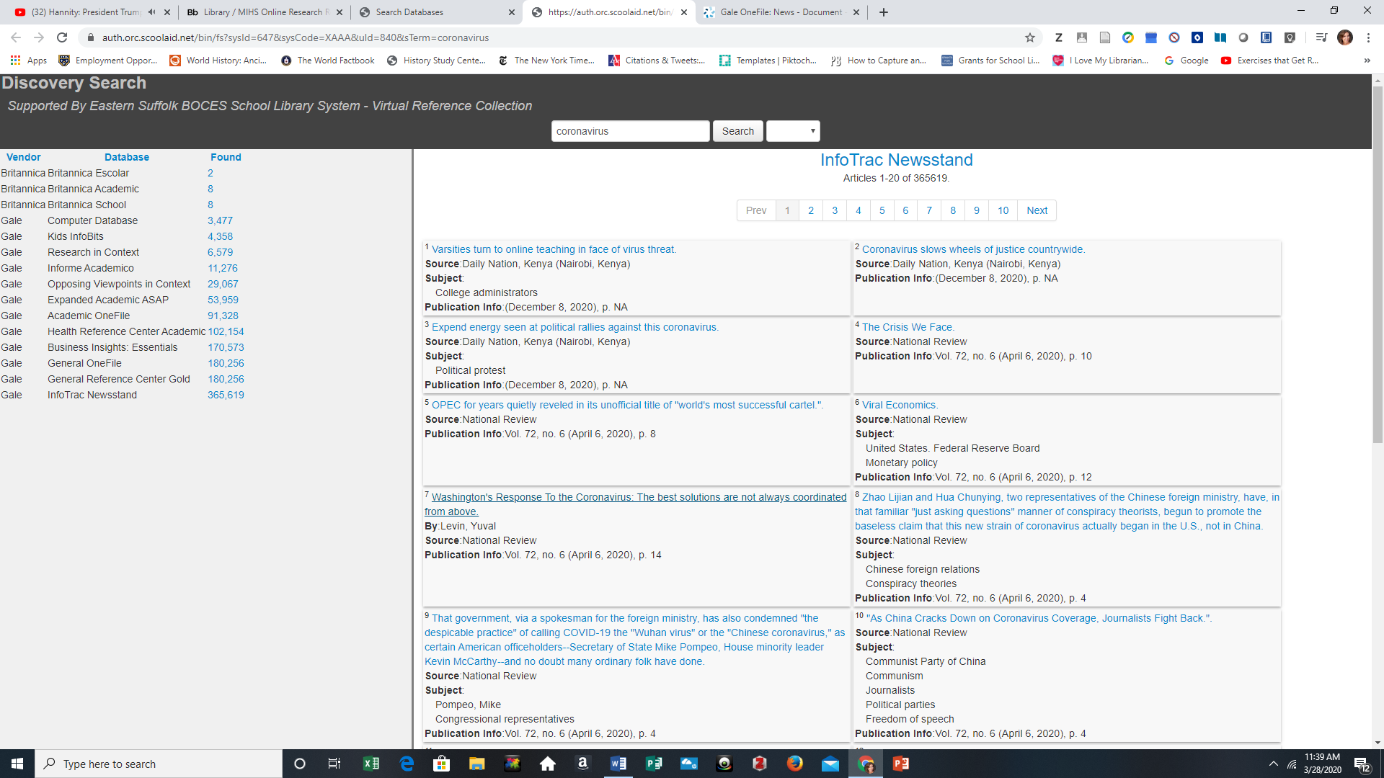
*Remember you can click on any database by subject and search the whole database
