Summer Reading List for Students Entering the 9th Grade

FICTION
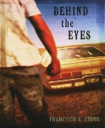Behind the Eyes by Francisco X. Stork
Hector has spent his sixteen years in the projects of El Paso trying to stay unnoticed. His peaceful obscurity is shattered when his impulsive brother challenges the leader of a gang. Hector tries to escape by going away to a school for students with troubled pasts. However, it is not easy to function when he is paralyzed by the fear.

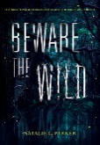Beware the Wild by Natalie C. Parker
Sterling and her brother, Phin, have an argument that compels him to run into the town swamp—the one that strikes fear in all the residents of Sticks, Louisiana. Phin does not return. Instead, a girl named Lenora May climbs out, and now Sterling is the only person in Sticks who remembers her brother ever existed.
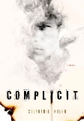Complicit by Stephanie Kuehn
Sixteen-year-old Jamie Henry breathed a sigh of relief when a judge sentenced his older sister to juvenile detention for burning down their neighbor's fancy horse barn. But, today Cate got out. Now she is coming back for Jamie. Because more than anything, Cate Henry needs her little brother to know this one truth: She is not the crazy one and never has been.
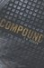 The Compound -Book 2: The Fallout by S.A. Bodeen
Eli and his family have lived in the underground Compound for six years. As problems with their carefully planned existence threaten to destroy their sanctuary—and their sanity—Eli cannot help but wonder if he would rather take his chances outside. Eli's father built the Compound to keep them safe. But are they safe—or sorry?

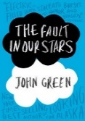Fault in our Stars by John Green
Despite the tumor-shrinking medical miracle that has bought her a few years, Hazel has never been anything but terminal, her final chapter inscribed upon diagnosis. But when Augustus Waters suddenly appears at Cancer Kid Support Group, Hazel's story is about to be completely rewritten.
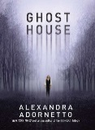Ghost House by Alexandra Adornetto
Alexander Reade is 157 years dead, with secrets darker than the lake surrounding Grange Hall, and a lifelike presence that draws Chloe more strongly than any ghost before. But the bond between them awakens the vengeful spirit of Alexander's past love, Isobel who will stop at nothing to destroy anyone who threatens to take him from her.

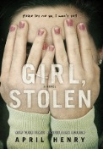Girl Stolen by April Henry
Sixteen-year-old Cheyenne is sleeping in the back of the car while the car is stolen. Griffin had not meant to kidnap Cheyenne and once he finds out that not only does she have pneumonia, but that she's blind, he doesn't know what to do. When his dad finds out that Cheyenne's father is the president of a powerful corporation, everything changes--now there is a reason to keep her.

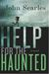Help for the Haunted by John Searles
Sylvie’s mother and father have an uncommon occupation helping "haunted souls" find peace. One late night they are lured to the old church on the outskirts of town. Once there, her parents disappear behind the church's red door, leaving Sylvie alone in the car. Not long after, she drifts off to sleep only to wake to the sound of gunfire.

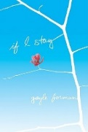If I Stay by Gayle Forman
Seventeen-year-old Mia is faced with some tough choices: Stay true to her first love—music—even if it means losing her boyfriend and leaving her family and friends behind?
Then one February morning Mia goes for a drive with her family, and in an instant, everything changes. Suddenly, all the choices are gone.

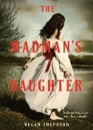The Madman’s Daughter -Book 2: The Dark Curiosity by Megan Shepherd
Sixteen-year-old Juliet has built a life for herself in London—working as a maid, and trying not to think about the scandal that ruined her life. After all, no one ever proved the rumors about her father’s gruesome experiments. But when she learns, he is alive and continuing his work on a remote tropical island, she is determined to find out if the accusations are true.
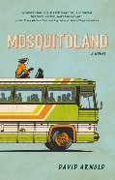Mosquitoland by David Arnold
Mim ditches her new life in the “wasteland” of Mississippi. Hopping aboard a northbound Greyhound bus to her real home and her real mother Mim meets a quirky cast of fellow travelers along the way. But when her thousand-mile journey takes a few turns, she could never see coming.

Miss Peregrine's Home for Peculiar Children by Ransom Riggs Book 2: Hollow City Book 3: Library of Souls
Sixteen-year-old Jacob, having traveled to a remote island after a family tragedy, discovers an abandoned orphanage, and after some investigating, he learns the children who lived there may have been dangerous and quarantined and may still be alive.

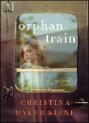Orphan Train by Christina Baker Kline
Two very different women who build an unexpected friendship: a 91-year-old woman with a hidden past as an orphan-train rider and the teenage girl whose own troubled adolescence leads her to seek answers to questions no one has ever thought to ask.
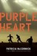 Purple Heart by Patricia McCormick
While recuperating in a Baghdad hospital from a traumatic brain injury sustained during the Iraq War, eighteen-year-old soldier Matt Duffy struggles to recall what happened to him and how it relates to his ten-year-old friend, Ali.

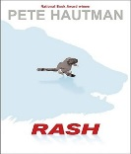Rash by Peter Hautman
Bo is unjustly accused of a causing a rash that plagues his entire high school. He loses it, and as a result, he is sentenced to work in the Canadian tundra, at a pizza factory that is surrounded by hungry polar bears. Bo finds prison life to be both boring and dangerous, but it is nothing compared to what happens when he starts playing on the factory's illegal football team.

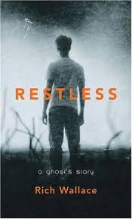Restless: A Ghost’s Story by Rich Wallace
Herbie is about to enter his senior year of high school. Herbie is nothing short of an exceptional teenager, but he is also a prime conduit for ghostly energy. And Herbie's brother, who died ten years ago, is desperately trying to make contact. Herbie may be Frank's only way to get free.

Sorta Like a Rock Star by Matthew Quick
Although Amber Appleton lives in a school bus with her unfit mother, she is a relentless optimist who helps everyone, but eventually she experiences one burden more than she can bear.

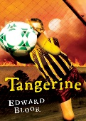Tangerine by Edward Bloor
Paul Fisher has to wear glasses so thick he looks like he is bug eyed, but he is not so blind to all the unusual things that are happening in his hometown, Tangerine. The sinkhole that swallowed a local school or the underground fire that has been burning for years and the lightning that strikes the same time every day.

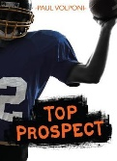Top Prospect by Paul Volponi
When Travis’s older brother joins the elite football program at Gainesville University, Gainesville’s head coach makes Travis a once-in-a-lifetime promise: Travis will have a place on the team too, and a scholarship to go with it. He just has to get through high school first.
Travis has to earn his teammates’ trust and dodge opponents aiming to sack the star quarterback. But his biggest challenge might be staying focused in the face of sudden fame.

A Tree Grows in Brooklyn by Betty Smith
Young, sensitive, and idealistic Francie Nolan spends her bittersweet formative years in the slums of Williamsburg, Brooklyn in 1912. The daily experiences of the Nolan family are raw with honesty and family connectedness.

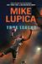 True Legend by Mike Lupica
Fifteen-year-old Drew "True" Robinson loves being the best point-guard prospect in
High school basketball but learns the consequences of fame through a former player as through the man who expects to be his manager when True reaches the NBA.
NON-FICTION

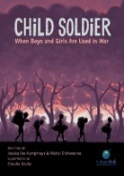
Child Soldier: When Boys and Girls Are Used in War by Jessica Dee Humphreys and Michael Chikwanine
Michel is like many other five-year-olds: he has a loving family and spends his days going to school and playing soccer. In 1993, the Democratic Republic of Congo, where Michel and his family live, is a country in tumult. One afternoon Michel and his friends are kidnapped by rebel militants and forced to become child soldiers.
Glass Castle by Jeannette Walls 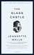
The second child of an alcoholic father and eccentric artist mother discusses her family’s nomadic upbringing from Arizona to Las Vegas to an Appalachian mining town where her siblings and she fended for themselves while their parents outmaneuvered bill collectors and the authorities.
His name was Raoul Wallenberg by Louise Borden 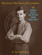
An amazing and inspirational World War II story about how one man saved the lives of many.

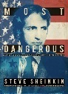Most Dangerous: Daniel Ellsberg and the Secret History of the Vietnam War by Steve Sheinkin
A thrilling journalistic account of a government insider Daniel Ellsberg who leaked the Pentagon Papers and exposed the decision that led to the US involvement in Vietnam.

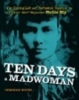Ten Days a Madwoman: The Daring Life and Turbulent Times of the Original “Girl” Reporter Nellie Bly by Deborah Noyes
Fresh off a train from Pittsburgh, Nellie knew she was destined for more and pulled a major journalistic stunt that skyrocketed her to fame: feigning insanity, being committed to the notorious asylum on Blackwell's Island, and writing a shocking exposé of the clinic’s horrific treatment of its patients.
Unstoppable: True Stories of Amazing Bionic Animals by Nancy Furstinger 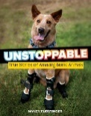
A collection of courageous stories shows how 3- D printing and brain controlled prosthetics are helping animals right now.

FICTION
  - Summer Reading List for Students Entering the 10th Grade

The Berlin Boxing Club by Robert Sharenow
Karl Stern has never thought of himself as a Jew. But the bullies at his school in Nazi-era Berlin. Demoralized by attacks on a heritage he does not accept as his own, Karl longs to prove his worth.

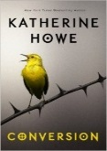 Conversion by Katherine Howe
A mystery illness is spreading through St. John’s Academy in Danvers Massachusetts. Students are coming down with symptoms of tics, hair loss, seizures and coughing fits. As panic and the media descend on the small town, it is discovered that it was once a Salem Village.

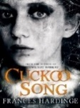 Cuckoo Song by Frances Hardinge
When Triss wakes up after an accident, she knows that something is very wrong. She looks through her diary to try to remember, but the pages have been ripped out. In a quest to find the truth she must travel into the terrifying underbelly of the city to meet a twisted architect
who has dark designs on her family.

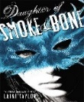Daughter of Smoke and Bone by Laini Taylor Book 2: Days of Blood & Starlight Book 3: Days of Gods & Monsters
In the tangled lanes of Prague, a young art student, Karou, is about to be caught up in a brutal otherworldly war. She fills her sketchbooks with monsters that may or may not be real, she is prone to disappearing on mysterious "errands", she speaks many languages - not all of them human - and her bright blue hair actually grows out of her head that color. Who is she?

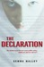 The Declaration by Gemma Malley
In 2140 England, where drugs enable people to live forever and children are illegal, Anna, an obedient "Surplus" training to become a house servant, discovers her birth parents are trying to find her.

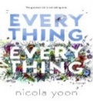Everything Everything by Nicola Yoon
My disease is as rare as it is famous. Basically, I’m allergic to the world. I have not left my house in seventeen years. Then one day, a moving truck arrives next door. I look out my window, and I see him. He catches me looking and stares at me. I stare right back. His name is Olly.
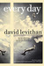 Every Day by David Levitan
Waking up in the body of a different person every day and struggling to pass through without raising alarm, "A" endures his existence before falling in love.

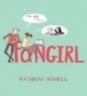 Fangirl by Rainbow Rowell
For Cath, being a fan is her life. It is what got her and her sister through their mother leaving. Cath’s sister, Wren has mostly grown away from fandom, but Cath cannot let go. Now that they are going to college, Wren has told Cath she does not want to be roommates. Cath is on her own, completely outside of her comfort zone.

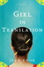Girl in Translation by Jean Kwok
Emigrating with her mother from Hong Kong to Brooklyn, Kimberly begins a double life as a schoolgirl by day and sweatshop worker at night. An existence also marked by her first crush and the pressure to save her family from poverty.

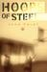 Hoops of Steel by John Foley
Passionate about basketball, troubled teenager Jackson O'Connell chronicles the ways the game colors the events of his senior year in high school.

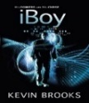iBoy by Kevin Brooks
Tom Harvey is an average kid until one day he has a fatal accident with his iPhone and as a result, he becomes more than just a normal boy. With his new powers, he has to decide if he is going to take the law into his own hands and avenge his girlfriend’s attackers.

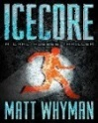 Icecore: a Carl Hobbes thriller by Matt Whyman
When Carl Hobbes hacks, Fort Knox he finds out it is no joke. Carl finds himself in an Arctic military prison next to notorious terrorists and has to start thinking like a criminal mastermind to escape his subzero prison.

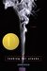 Looking for Alaska by John Green
Miles Halter's whole existence has been one big nonevent. He heads off to Culver Creek Boarding School, and his life becomes the opposite of safe. Down the hall is Alaska Young, the gorgeous, clever, funny, sexy, self-destructive, and utterly fascinating Alaska Young, who is an event unto herself.

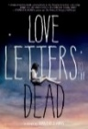Love Letters to the Dead by Ava Dellaira
It began as an assignment for English class: write a letter to a dead person. Laurel chooses Kurt Cobain because her sister, May, loved him. And he died young, just like May. She writes about learning to live with her splintering family, falling in love for the first time, trying to grieve for May. But how do you mourn for someone you haven't forgiven?

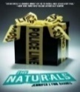 The Naturals by Jennifer Lynn Barnes
Seventeen-year-old Cassie becomes part of a classified FBI program and soon finds herself in the middle of a cat and mouse chase involving a serial killer.

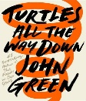Turtles All The Way Down by John Green
Aza never intended to pursue the mystery of fugitive billionaire Russell Pickett, but there is a hundred-thousand-dollar reward at stake and her Best and Most Fearless Friend, Daisy, is eager to investigate. So together, they navigate the short distance and broad divides that separate them from Russell Pickett’s son, Davis.

NON-FICTION

The Blind Side: Evolution of a Game by Michael Lewis 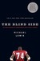
This story follows one young man from his impoverished childhood with a crack-addicted mother. Through his discovery of the sport of football, to his rise to become one of the most successful highly paid players in the NFL.

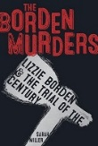The Borden Murders: Lizzie Borden & the Trial of the Century by Sarah Miller
Most of what is known about Lizzie’s arrest and subsequent trial (and acquittal) comes from sensationalized newspaper reports; as Miller sorts fact from fiction, and as a legal battle gets under way, a portrait of a woman and a town emerges.

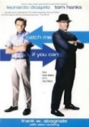Catch Me If You Can: A True Story of a Real Fake by Frank W. Abagnale
Partied in every capital in Europe and basked on all the world's most famous beaches'. Frank W Abagnale, alias Frank Williams, Robert Conrad, Frank Adams and Ringo Monjo, was one of the most daring con men, forgers, imposters and escape artists in history.
Chinese Cinderella: the true story of an unwanted daughter 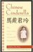
by Adeline Yen Mah
Adeline's affluent, powerful family considers her bad luck after her mother dies giving birth to her. She and her siblings are subjected to the disdain of her stepmother, while her stepbrother and stepsister are spoiled. Although Adeline wins prizes at school, they are not enough to compensate for what she really yearns for -- the love and understanding of her family.

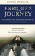Enrique’s Journey: The Story of a Boy’s Dangerous Odyssey to Reunite with his Mother by Sonia Nazario
Enrique a Honduran boy searching for his mother after she is forced to leave her starving family to find work in the United States. Braving unimaginable peril, often clinging to the sides and tops of freight trains, Enrique travels through hostile worlds full of thugs, bandits, and corrupt cops.

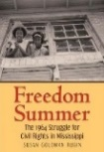Freedom Summer: the 1964 Struggle for Civil Rights in Mississippi by Susan Goldman Rubin
Fannie Lou Hamer, a native of the Mississippi Delta who had tried to register to vote but was twice denied and Andrew Goodman, a white 20-year old man who volunteered to assist in registering blacks to vote, becoming part of the Freedom Summer. Less than a week after leaving home, Andrew Goodman was dead.
A long way gone: Memoirs of a Boy Soldier by Ishmael Beah 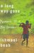
This is how wars are fought now: by children, hopped-up on drugs and wielding AK-47s. Children have become soldiers of choice. In the more than fifty conflicts going on worldwide, it is estimated that there are some 300,000-child soldiers. Ishmael Beah used to be one of them.

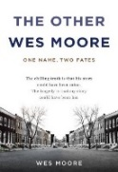The Other Wes Moore: One Name, Two Fates by Wes Moore
Two kids with the same name lived in the same decaying city. One went on to be a Rhodes Scholar, decorated combat veteran, White House Fellow, and business leader. The other is serving a life sentence in prison. Here is the story of two boys and the journey of a generation.

Sabotage: The Mission to Destroy Hitler’s Atomic Bomb by Neal Bascomb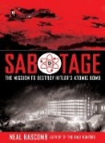
The invasion begins at night, with German cruisers slipping into harbor, and soon the Nazis occupy all of Norway. They institute martial rule. At Vemork, an industrial fortress, they gain access to an essential ingredient for the weapon that could end World War II: Hitler’s very own nuclear bomb.

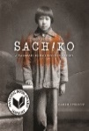Sachiko: A Nagasaki Bomb Survivor’s Story by Caren Stelson
Six-year-old Sachiko Yasui's survival of the Nagasaki atomic bomb on August 9, 1945, and the lifelong aftermath. Having conducted extensive interviews with Sachiko Yasui, Caren Stelson chronicles Sachiko’s trauma and loss as well as her long journey to find peace.

Heal: The Vital Role of Dogs in the Search for Cancer Cures by Arlene Weintraub
Explore the fascinating role dogs are playing in the search for a cure for cancer. Learn how veterinarians and oncologists are working together to discover new treatments. Heal introduces readers to the field of comparative oncology by describing several research projects aimed at finding new therapies for cancers that are similar in dogs and people.

FICTION
Summer Reading List for Students Entering the 11th Grade
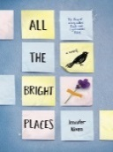All the Bright Places by Jennifer Niven
When Finch and Violet meet on the ledge of the bell tower at school, it is unclear who saves whom. It is only with Violet that Finch can be himself—a weird, funny, live-out-loud guy who’s not such a freak after all. And it is only with Finch that Violet can forget to count away the days and start living them.

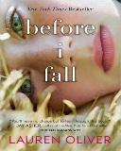Before I Fall by Lauren Oliver
For popular high school senior Samantha Kingston, February 12—"Cupid Day"—should be one big party. And it is…until she dies in a terrible accident that night. However, she still wakes up the next morning. Sam lives the last day of her life seven times, until she realizes that by making even the slightest changes, she may hold more power than she ever imagined.

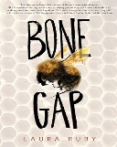 Bone Gap by Laura Ruby
Everyone knows Bone Gap is full of gaps—gaps to trip you up, gaps to slide through so you can disappear forever. So when Roza went missing, the people of Bone Gap were not surprised. Finn knows that’s not what happened. He knows she was kidnapped, by a dangerous man whose face he cannot remember. But the searches turned up nothing, and no one believes him anymore.

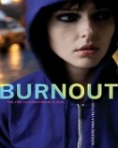Burnout by Adrienne Maria Vrettos
On the day after Halloween, Nan wakes up in a subway car. She does not know where she has been or what she has done. And she is wearing skeleton makeup and a too-small Halloween costume that she doesn't remember putting on. She needs to find out what happened to her.

The Cellar by Natasha Preston
Sixteen-year-old Summer disappears without a trace. No family or police investigation can track her down. Spending months inside the cellar of her kidnapper with several other girls, Summer learns of Colin’s abusive past. His thoughts of his victims being his family…his perfect, pure flowers. But flowers cannot survive long cut off from the sun, and time is running out.

Compulsion by Heidi Ayarbe
Jake is convinced the magic will be permanent after Saturday, the perfect day, when every prime has converged. Once the game is over, he won't have to rely on his sister to concoct excuses for his odd rituals. His dad will stop treating him like he is some freak.
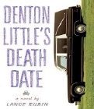Denton Little’s Death Date by Lance Rubin Book 2:Denton Little’s Still Not Dead: Now He Needs To Get a Life
Denton Little's Death date takes place in a world exactly like our own except that everyone knows the day they will die. When a strange man shows up at his funeral, claiming to have known Denton's long-deceased mother, and warning him to beware of suspicious government characters. Suddenly Denton's life is filled with mysterious questions and precious little time to find the answers.

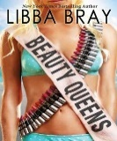 Beauty Queens by Libba Bray
When a plane crash strands thirteen teen beauty contestants on a mysterious island, they struggle to survive, to get along with one another, to combat the island's other diabolical occupants, and to learn their dance numbers in case they are rescued in time for the competition.

Eleanor and Park by Rainbow Rowell
Set over the course of one school year in 1986, this is the story of two star-crossed misfits--smart enough to know that first love almost never lasts, but brave and desperate enough to try.

Hate List by Jennifer Brown
After her boyfriend goes on a shooting rampage at school, Valerie is implicated because of her involvement in writing the list of names and now must come to terms with what happened and the part she played that resulted in such tragic events.

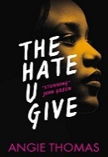The Hate U Give by Angie Thomas
Starr lives in two worlds: the poor neighborhood where she was born and raised and her posh high school in the suburbs. Starr is the only witness to the fatal shooting of her unarmed best friend, Khalil, by a police officer. Now what Starr says could destroy her community. It could also get her killed.

Oblivion by Sasha Dawn
The anniversary of Hannah’s disappearance is approaching and Callie is plagued with more memories and words that make no sense to her. She tries to unlock her past with the help of a guy she meets at school.
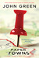Paper Towns by John Green
One month before graduating from his Central Florida high school, Quentin "Q"
Jacobsen basks in his predictable life until his beautiful and exciting neighbor and classmate, takes him on a midnight adventure and then mysteriously disappears.
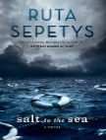Salt to the Sea by Ruth Sepetys
Winter, 1945. Four teenagers. Four secrets. Each one born of a different homeland; each one hunted, and haunted, by tragedy, lies and war. As thousands of desperate refugees flock to the coast in the midst of a Soviet advance, four paths converge, vying for passage aboard the Wilhelm Gustloff, a ship that promises safety and freedom.
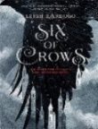Six of Crows by Leigh Bardugo Book 2: Crooked Kingdom
Kaz needs a crew desperate enough to take on this suicide mission and dangerous enough to get the job done - and he knows exactly who: six of the deadliest outcasts the city has to offer. Together, they just might be unstoppable - if they don't kill each other first.
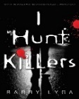I Hunt Killers- Book 2: Game by Barry Lyga
Jasper is a likable teenager. But he's also the son of the world's most infamous serial killer, and for Dear Old Dad, Take Your Son to Work Day was year-round. Jazz has witnessed crime scenes from the criminal's point of view. And now bodies are piling up in Lobo's Nod. In an effort to clear his name, Jazz joins the police in a hunt for a new serial killer.
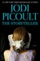The Storyteller by Jodi Picoult
Sage Singer is a baker and works through the night, preparing the day’s breads and pastries, trying to escape a reality of loneliness, bad memories, and the shadow of her mother’s death. When Josef Weber, an elderly man in Sage’s grief support group, begins stopping by the bakery, they strike up an unlikely friendship.

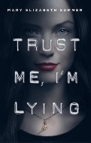Trust Me, I’m Lying by Mary Elizabeth Summer
Julep Dupree is an expert at telling lies, after all she learned from the best, her father. When Julep comes home to a ransacked apartment, she follows the clues left behind by her father leading her to an underground mob ring.
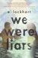We Were Liars by E. Lockheart
Four friends turn against each other in the wake of trauma, differing political views and a devastating secret.

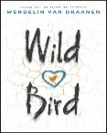Wild Bird by Wendelin Van Draanen
3:47 a.m. That's when they come for Wren Clemens. She's hustled out of her house and into a waiting car, then a plane, and then taken on a forced march into the desert. This is wilderness therapy camp. The Wren who arrives in the Utah desert is angry and bitter, and blaming everyone but herself. But angry can't put up a tent. And bitter won't start a fire. Wren's going to have to admit she needs help if she's going to survive.

NON-FICTION
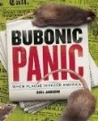Bubonic Panic: When Plague Invaded America by Gail Jarrow
The true story of America’s first plague epidemic—the public health doctors who desperately fought to end it, the political leaders who tried to keep it hidden, and the brave scientists who uncovered the plague’s secrets.
Defiance: The Bielski Partisans by Nechama Tec 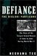
A forest community in western Belorussia with more than 1,200 Jews by 1944, risking their lives against overwhelming odds for the slimmest chance of survival, or a glimpse of freedom, the largest armed rescue operation of Jews by Jews in World War II.

Fast Food Nation: The Dark Side of the All-American Meal 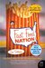
by Eric Schlosser
Fast food has widened the chasm between rich and poor, fueled an epidemic of obesity, and propelled American cultural imperialism abroad. That's a lengthy list of charges, but Schlosser makes them stick with careful reasoning.

The Innocent Man: Murder and Injustice in a small town by john Grisham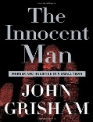
Ron Williamson, in 1971 was the first major league player chosen from the State of Oklahoma. Six years later, a bad arm and bad habits broke his dreams. In 1982, a 21-year-old named Debra Sue Carter was murdered. The prosecution’s case was built on junk science and the testimony of jailhouse snitches and convicts. Ron Williamson was sent to death row.
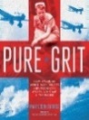 Pure Grit: How American World War II Nurses Survived Battle and Prison Camp in the Pacific by Mary Cronk Farrell American Army and Navy nurses serving in the jungle hospitals in the Philippines and in underground tunnels were captured by the Japanese as prisoners of war where they suffered disease and near-starvation for three years.

Poisoner’s Handbook: Murder and the Birth of Forensic Medicine in 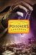
Jazz Age New York by Deborah Blum
Highly original research to track the fascinating, perilous days when a pair of forensic scientists began their trailblazing chemical detective work, fighting to end an era when untraceable poisons offered an easy path to the perfect crime.

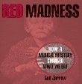Red Madness: How a Medical Mystery Changed What We Eat by Gail Jarrow
One hundred years ago, the American South was plagued with a disease that left a hundred thousand people weak, disfigured, insane and sometimes dead. Red Madness includes stories of real life pellagra victims and accounts of scientific investigations.

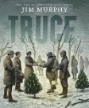Truce: The Day the Soldiers Stopped Fighting by Jim Murphy
On July 29 1914, the world’s peace was shattered as the artillery of the Austria-Hungary Empire began shelling the troops of the country to its south. On December 25, the troops would openly defy their commanding officers by stopping the fighting.

Summer Reading List for Students Entering the 12th Grade
FICTION
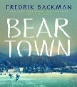Beartown by Frederik Backman
People say Beartown is finished. Down by the lake stands an old ice rink, built generations ago by the workers who founded this town. The junior ice hockey team is about to compete in the national semi-finals, and they actually have a chance at winning. All the hopes and dreams of this place now rest on the shoulders of a handful of teenage boys.

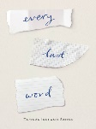Every Last Word by Tamara Ireland Stone Samantha, a sophomore in high school, was diagnosed with OCD at age eleven. She meets Caroline, a school outcast who shows her poet’s corner, a place where you can write without being interrupted, cry without being judged and be in an environment that will keep you from losing yourself. Samantha’s life begins to take new shape when falls more toward the AJ, which is who she teased nonstop in fourth grade and made him switch schools.

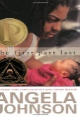The First Part Last by Angela Johnson
Bobby is a classic urban restless and impulsive teenager. The thing that makes him different is this: He is going to be a father. His girlfriend, Nia, is pregnant, and their lives are about to change forever. Instead of spending time with friends, they will be spending time with doctors, and next, diapers. They have options: keeping the baby, adoption. They want to do the right thing. If only it was clear, what the right thing was.

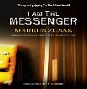I am the Messenger by Markus Zusak
Ed Kennedy is an underage cabdriver without much of a future. He is pathetic at playing cards, hopelessly in love with his best friend, Audrey, and utterly devoted to his coffee-drinking dog, the Doorman. His life is one of peaceful routine and incompetence until he inadvertently stops a bank robbery.

If You Find Me by Emily Murdoch
A broken-down camper hidden in a national forest is the only home fifteen year-old Carey and Carey’s younger sister, Jenessa, can remember. Until one day, their mentally ill mother disappears, and two strangers arrive. Carey must face the truth of why her mother abducted her and the reason Jenessa has not spoken a word in over a year.
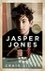Jasper Jones by Craig Silvey
Charlie Bucktin is startled one summer night by an urgent knock on his bedroom window. His visitor is Jasper Jones, an outcast in their small mining town, and he has come to ask for Charlie's help. Charlie follows him into the night. Jasper takes him to his secret glade, where Charlie witnesses Jasper's horrible discovery.

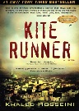The Kite Runner by Khaled Hosseini
Amir is the son of a wealthy Kabul merchant and his servant and constant companion, is a Hazara, a despised and impoverished caste. Their uncommon bond is torn by Amir's choice to abandon his friend amidst the increasing tensions of the dying years of the Afghan monarchy. The bond between the two boys is so strong that Amir will journey back to right past wrongs against the only true friend he ever had.

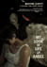My Book of Life By Angel by Martine Leavitt
Sixteen-year-old Angel meets Call at the mall, he buys her meals and says he loves her, and he gives her some candy that makes her feel like she can fly. Pretty soon she's addicted to his candy, and she moves in with him. As a favor, he asks her to hook up with a couple of friends of his, and then a couple more. Now Angel is stuck working the streets.

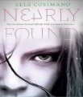Nearly Found by Elle Cosimano
Nearly, Reece, and Nearly's classmates--Vince, Jeremy, and Eric--start a dangerous investigation into their fathers' pasts that threatens Nearly's fragile romance with Reece, and puts all them in the killer's path.

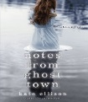Notes from Ghost Town by Kate Ellison
When the ghost of her first love, Lucas Stern, visits sixteen-year-old artist Olivia Tithe it is only through scattered images and notes left behind that she could unravel the mystery of his death.

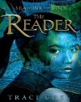The Reader by Traci Chee
Sefia lives her life on the run. After her father is viciously murdered, she flees to the forest with her aunt Nin, the only person left she can trust. However, when Nin is kidnapped, Sefia is suddenly on her own, with no way to know who has taken Nin or where she is. Her only clue is a book.

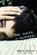Rules of Survival by Nancy Werlin
For Matt and his sisters, life with their cruel, physically abusive mother is a day-to-day struggle for survival. Matt witnesses a man named Murdoch coming to a child’s rescue in a convenience store. Then, Murdoch begins dating Matt’s mother and life is suddenly almost good. When Murdoch inevitable breaks up with their mother, Matt knows he will need to take some action.

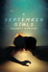September Girls by Bennett Madison
Whisked away by his father to an unusual beach town in the Outer Banks, Sam finds himself having the summer vacation surrounded by beautiful blonde girls, and, better yet, they all seem inexplicably attracted to him. But there's definitely something strange about the Girls.

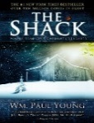The Shack by William Paul Young
Missy has been abducted during a family vacation, and evidence that she may have been brutally murdered is found in an abandoned shack deep in the Oregon wilderness. Mack receives a suspicious note inviting him back to that shack for a weekend.

Shine by Lauren Myracle
When her friend is a victim of a vicious hate crime, sixteen-year-old Cat sets out to discover who in her small town did it. She uncovers the secrets of a tightly knit Southern community and what it will take to go against everyone she knows in the name of justice.

Skinny by Donna Cooner
Hopeless, Freak, Elephant, Pitiful are the words of Skinny, the voice that lives inside fifteen-year-old Ever Davies’s head. Skinny tells her all the dark thoughts her classmates have about her. But there is another voice: Ever’s singing voice, which has been silenced by Skinny. Ever decides to undergo a risky surgery that may help her lose weight and start over.

Sold by Patricia McCormick
Thirteen- year- old Lakshmi lives in a hut in the mountains of Nepal. When the family crops are destroyed from a monsoon, her stepfather sends her to work for a glamorous stranger in her “Happiness House” where her nightmare begins.

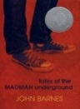Tales of the Madman underground by John Barnes
Karl Shoemaker has a theory- he will be normal for his senior year and overcoming his membership in the Madman Underground (a group of kids forced to attend group therapy during school hours).

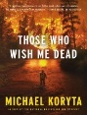Those Who Wish Me Dead by Michael Koryta
When Jace Wilson witnesses a brutal murder he is issued a false identity and hidden in a wilderness skills program for troubled teens. The plan is to get off the grid while police find the two killers. The result is the start of a nightmare.

NON-FICTION

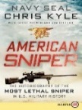American Sniper:The Autobiography of the Most Lethal Snipe in U.S. Military History by Chris Kyle
A native Texan who learned to shoot on childhood hunting trips with his father, Kyle was a champion saddle-bronc rider prior to joining the Navy. After 9/11, he was thrust onto the front lines of the War on Terror, and soon found his calling as a world-class sniper who performed best under fire. Kyle talks honestly about the pain of war—of twice being shot and experiencing the tragic deaths of two close friends.

Blood Brothers: Jonathan Daniels and His Sacrifice for Civil Rights by 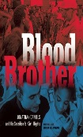Calkins Creek
Jonathan Daniels, a white seminary student from New Hampshire, traveled to Selma, Alabama, in 1965 to help with voter registration of black residents. After the voting rights marches, he remained in Alabama, in the area known as “Bloody Lowndes,” an extremely dangerous area for white freedom fighters, to assist civil rights workers. Five months later, Jonathan Daniels was shot and killed while saving the life of Ruby Sales, a black teenager.

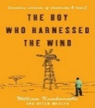The Boy Who Harnessed the Wind: Creating Currents of Electricity and Hope by William Kamkwamba
William Kamkwamba was born in Malawi, a country where magic ruled and modern science was mystery. It was also a land withered by drought and hunger, and a place where hope and opportunity were hard to find. But William had read about windmills in a book called Using Energy, and he dreamed of building one that would bring electricity and water to his village.

The Boys Who Challenged Hitler: Knud Pedersen and the Churchill Club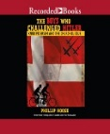 by Phillip Hoose
Naming their secret club the Churchill Club, the young patriots committed countless acts of sabotage against the Germans, who eventually had the boys tracked down and arrested. The boys' exploits and eventual imprisonment helped spark a full-blown Danish resistance.

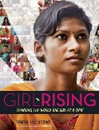Girl Rising: Changing the World One Girl at a Time by Tanya Lee Stone
Girl Rising, a global campaign for girls’ education, created a film that chronicled the stories of nine girls in the developing world, allowing viewers the opportunity to witness how education can break the cycle of poverty.
Immortal Life of Henrietta Lacks by Rebecca Skloot 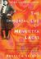
Her name was Henrietta Lacks, but scientists knew her as HeLa. She was a poor Southern
Tobacco farmer who worked the same land as her slave ancestors, yet her cells—taken without her knowledge—became one of the most important tools in medicine. The first "immortal" human cells grown in culture, they are still alive today!

Outliers: The Story of Success by Malcolm Gladwell 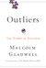
Malcolm takes us on an intellectual journey through the world of “outliers” – the best and the brightest, the most famous and the most successful. He asks the question: what makes high achievers different?
Unbroken: a World War II Airman's Story of Survival, Resilience, 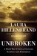
And Redemption by Laura Hillenbrand
The gripping true story of a U.S. airman who was the sole survivor when his bomber crashed into the sea during World War II and had to face thousands of miles of ocean, leaping sharks, a foundering raft, thirst and starvation, and enemy aircraft.

Strike! The Farm Workers’ Flight for their Rights by Larry Dane Brimmer 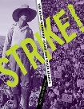
Migrant Filippino American workers strike when the California growers refuse to pay them the same rate as the guest workers from Mexico. Setting off the most successful strike in American history.

Reading lists and summaries adapted from American Library Association and YALSA Notable Books 2018 and Goodreads

Updated 5/18 AP

